**CONTENTS**

1. INTRODUCTION TO BUILDING RELOCATION
   1. TECHNICAL CONSIDERATIONS
   2. MOTIVATION TO MOVE BUILDINGS
   3. TYPES OF MOVING BUILDINGS
   4. EQUIPMENTS REQUIRED
   5. THE RELOCATION PROCESS
   6. ESTIMATED COST
   7. DISADVANTAGES
   8. SOME OF THE RELOCATION PROJECTS
   9. GALLERY
2. UNDERPINNING
   1. SELECTION OF UNDERPINNING METHODS
   2. METHODS OF UNDERPINNING
   3. COMMON PROBLEMS IN UNDERPINNING
   4. BENEFITS OF UNDERPINNING SYSTEM
   5. GALLERY
3. CONCLUSION
4. AVAILABLE RESOURCES

**1.INTRODUCTION**

**BUILDINGS RELOCATION**

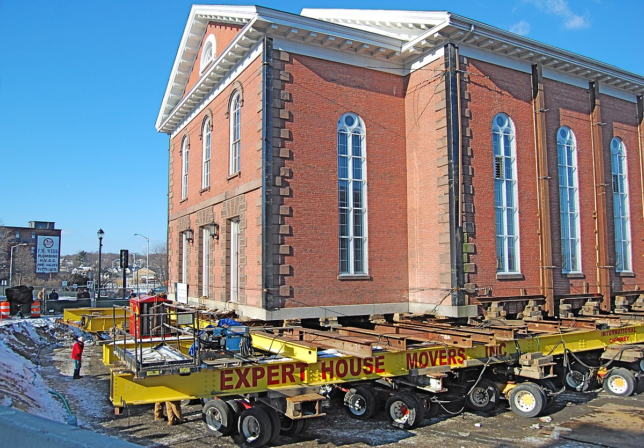

A structure relocation is the process of moving a structure from one location to another.

There are two main ways for a structure to be moved: disassembling and then reassembling it at the required destination, or transporting it whole.

For the latter, the building is first raised and then may be pushed on temporary rails or dollies if the distance is short. Otherwise, wheels, such as flatbed trucks, are used. These moves can be complicated and require the removal of protruding parts of the building, such as the chimney, as well as obstacles along the journey, such as overhead cables and trees.

There are a number of reasons why a structure may need to be moved. There could be commercial reasons, it may be necessary to free up the plot of land that it stands on, it may be sold to a new owner and so on. It is also an increasingly common method of preserving important or historic buildings that may be threatened by flooding, redevelopment, adverse ground conditions, and so on.

If the method selected is to move the structure in one piece, then very careful planning and coordination is required. Typically, the process begins with openings being cut in the building’s foundation. This allows the installation of a temporary framework attached underneath for structural support.

Hydraulic jacks are installed under the framework that are connected to a central control system. This system monitors the pressure on each jack and helps to keep the building level as it is lifted up off the foundation. The structure may be elevated in increments using cribs (large timber beams) that are stacked into piles as a means of supporting the hydraulic jacks that are re-positioned gradually higher on them. Once raised to a sufficient height, the buildings ready to be transported.

If the distance is relatively short, temporary rails or hydraulic dollies can be placed under the framework to enable it to move. If the distance is greater, flatbed trucks are used. In this case, projections such as chimneys may need to be removed and the journey planned to allow for obstacles en route such as trees and overhead cables. Once the move is complete, the structure is lowered onto a newly prepared foundation by reversing the above steps.

Some modern modular buildings may be designed to be re-locatable. This may be possible without disassembly, or may require some separation of parts. Site huts on construction sites are an example of modular buildings that can be taken apart, moved, and reconfigured for another use. Increasingly other construction buildings are also re-locatable, such as pre-fabrication and manufacturing facilities. See flying factory for more information.

Disassembling buildings that were not designed for relocation is a complex process that requires careful planning and meticulous record keeping. This is only likely to be necessary for buildings that are important or protected, such as historically significant buildings.

Some structures are intended to be disassembled and relocated, such as live events structures which may tour from one location to another. In this case, the components are designed to be dismantled, transported and re-assembled.

Increasingly, permanent buildings are also being ‘designed for deconstruction’, that is they are constructed in a way that will make it easier to take them apart and use the components again, either at the end of their life, or for relocation.

Relocation is most appropriate in areas where the flood conditions are characterized by one or more of the following:

* Deep water
* Short warning time (flash flooding)
* High flow velocity
* Wave action
* Significant quantity of debris in floodwaters

**1.1.Technical Considerations**

Technical considerations for a relocation project include structure type, condition, and size.

**Structure Type**

Structures that are easiest to elevate, such as a single-story wood-frame structure over a crawlspace or basement foundation with a simple rectangular shape, are also the easiest to relocate. Concrete, masonry, or brick faced structures require special attention to ensure that the structure is not damaged during the process. For a structure with wood-frame construction, with a brick veneer, the brick could be removed and then reapplied once the relocation process is complete.

**Structure Condition**

Structures best suited for relocation are those in good condition. All structural members and their connections must be able to withstand the stresses imposed when the structure is lifted and moved. A structure that is in poor condition, especially one that has been damaged by repeated or severe flooding, may need so much structural repair and bracing that relocation would not be practical.

Prior to beginning, a thorough analysis of both the existing site and structure and the new site must be made. The examination of the structure should be done by a licensed structural engineer, with particular attention given to the building’s floor support system (i.e., joists, plates, and flooring) to ensure that it will remain intact. If these components are not in good structural condition, the structure may not be a good candidate for relocation.

**1.2.Motivations to Move Buildings**

There are various factors that creates the need to move buildings from its original positions to new locations, for example, preserving historical structures from demolishing when its location is needed for industrial purposes or due to increase in population density new residential buildings are required to be built.

Another factor is that building have not been constructed based on proper plans and arrangements, so buildings are moved to provide desired arrangements.

It may be more economical to move the structure to the new location rather than demolishing it and then constructing new buildings.

There is situation in which the residential areas suffer from repeated catastrophic natural events such as flooding, so in this case moving buildings might be suitable option, for example, Clermont houses were moved due to the risk of flooding.

Moving buildings are structures which are relocated from its original location to new site. Different aspect of moving buildings with types of such buildings, process of moving are discussed.

Moving buildings are structures which are relocated from its original location to new site. Different aspect of moving buildings with types of such buildings, process of moving are discussed Historical houses are sometimes moved and collected to form a historical village

**1.3.Types of Moving Buildings**

Timber building, bearing wall buildings, and framed buildings are possible to be moved using necessary techniques and equipment.

In the following sections, procedures and methods used for moving buildings with bearing walls and framed buildings will be discussed

### ****Buildings with Bearing Walls****

If buildings with bearing walls are intended to be moved from its locations, then it is recommended to introduce holes in the wall and place needles at suitable spacing in order to provide supports for the brick works and prevent failure.

After that longitudinal beams are placed on each side of the walls followed by jacking up the beams against the needles. Then, carriage wheels or rollers are placed under the longitudinal beams or second set of girders, which may be provided as an extra level of precautions regarding even distribution of loads, beneath the beams.

These girders offer some advantages since not only lead to decline the number of carriages but also decrease number of required jacks.

As far the movement force is concerned, long stroke hydraulic jacks are commonly used to generate the force required to move the carriage along the track. The cylinders are joined to the rails and the rams work against the carriage.

Winching or jacking can be employed, but the latter approach is desired because detrimentally uncontrolled and jerky motion is likely to occur when the former technique is applied.

It is reported that the force that needed for the initial movement should be around 1 to 2% of the weight of the structure, and the forced required to have a continuous movement of the structure is claimed to be approximately two third of the force necessary to start the movement

### ****Moving Framed Buildings****

Measure need to undertake framed building involves needling and propping columns after that placing roller carriages under the support of a row of column or each column.

It is reported that, strut and ties can be employed in lower story or multi-storey framed buildings so as to transfer loads of columns to jacks. This will decrease the number of jacks required.

It is claimed that air cushion principle can be used to move structure especially those with flat or level bases such as storage tanks used to store patrols. When this method is considered for irregular buildings, necessary care should be practices regarding the possibility of losing air.

**1.4.EQUIPMENTS REQUIRED**

### POWER UNITS

### DOLLIES

### UNIFIED JACKING MACHINES

### CRIB JACKS

### PORTABLE POWER JACK

### JACKING SHORING POSTS

### NEEDLE BEAMS

### DIGGING PANS

### PUSH RAMS

### HEAVY HAUL BI-DIRECTIONAL SKATES

**1.5.The Relocation Process**

**Selecting the new site:** Selection of a new site for relocating a structure requires consideration of: natural hazards, utility connections, accessibility for site preparation, and the moving route between the old and new sites. Narrow roads, restrictive load capacities (of roads or bridges), low clearances (under bridges or power lines), or other restrictions along the route to the new site can complicate a relocation project. If an alternate route is not available, it may be necessary to move the structure in sections.

**Permitting:** All permits required for construction at the new site, for moving the building, and for restoring the old site should be obtained before the relocation project begins.

**Lifting the building:** If the building has a basement or crawlspace foundation, it is separated from the foundation and lifted on steel I-beams that pass through the foundation walls directly below the floor framing. The lifting is done with hydraulic jacks placed directly under the I-beams. Buildings with slab on-grade foundations are lifted with the concrete floor slab attached, so the I-beams are inserted below the slab.

**Preparing the new site**: Preparation of the new site includes: erosion control, grading/clearing (as needed), driveway construction, construction of a new foundation, and installation of utilities (electrical, gas, water, sewer, telephone, and cable).

**Moving the building:** Trailer wheel sets are placed beneath the building and attached. The building is towed to the new site, positioned over the partially completed foundation, and supported on cribbing while the foundation is completed below it. The building is lowered onto the new foundation and construction completed (utility connections, backfilling, landscaping, etc.)

**Restoring the old site:** Restoration of the abandoned site usually involves removal of the foundation and utilities, backfilling the basement, grading, and vegetative stabilization.

**1.6.Estimated Cost**

Relocation is a relatively expensive mitigation measure. In order to determine the estimated cost of a relocation project, contact one or more house movers. Provide basic data on the structure, such as wall and foundation type and size, and information on the distance to the new site. The movers should be able to provide a general cost estimate.

Examples of cost estimating items that may need to be considered include the following:

Analysis of existing site and structure

* Site selection and analysis and design of the new location (i.e., adequacy of the new location for the structure, utility connections, permits, etc.)
* Analysis and preparation of the moving route, including items such as the width of the road, obtaining approval and permits, and route preparation
* Preparation of the structure prior to the move, such as disconnecting utilities, preparing the structure for the lift, and separating the structure from its foundation
* Moving the structure to the new location
* Preparation of the new site
* Construction of the foundation at the new location
* Connection of the structure to the new foundation
* Restoration of the old site

**1.7.DISADVANTAGES**

* Relocation is only possible if the building is structurally sound.
* Cost may be prohibitive.
* A new site must be located and purchased.

Disposition of the flood-prone lot must be addressed.

* Additional costs may be incurred to bring the structure into compliance with current building codes for plumbing, electrical, and energy systems.
* Accuracy of the work should be hundred percent because any miscalculation can lead to huge disasters.
* Cannot be done in congestion Areas

**1.8.SOME OF THE RELOCATION PROJECTS IN INDIA**

1. 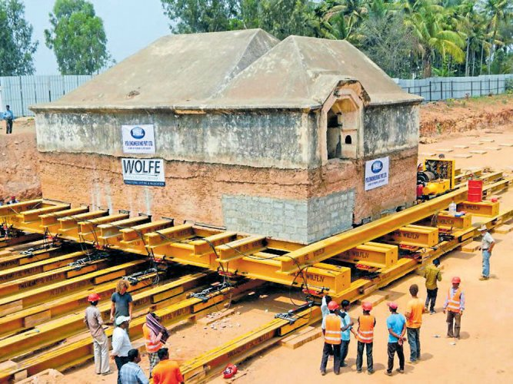**Tippu Sultan Armoury in Srirangapatna**

Tipu Sultan’s historical armoury at Srirangapatna is all set for relocation to another site, to pave way for the completion of the Bengaluru-Mysore rail track doubling work.

The armoury, a neglected square-shaped structure about 12 metres wide and ten metres tall, was used to store arms and ammunition by Tipu during the Anglo-Mysore wars.

The excavation around the 18th-century heritage structure in Srirangapatna has been completed, and hundreds of truck loads of soil from the site and across the half-buried structure shifted out.

The entire piece, weighing around 900 to 1,000 tonnes, was inspected by officials from the railways, Archaeological Survey of India and a two-member team from the United States.

**Sophisticated method**

The armoury will be relocated using the Unified Jacking System. Jacks, iron poles and other tools are inserted underneath the structure to lift and roll it to another site. Hydraulic cranes and other advanced equipment are to be used.

Shifting of the armoury structure, which is necessary for the completion of the Bengaluru-Mysuru track-doubling work, has missed several deadlines for the last five years. It bisects the alignment of the second track

**Cost of the Project**

Thus, the work to relocate the armoury at a cost of Rs. 13.66 crore has been awarded to PSL-Wolfe Private Limited, a joint venture company.

1. **Residential Building Relocation in Mettupalyam**

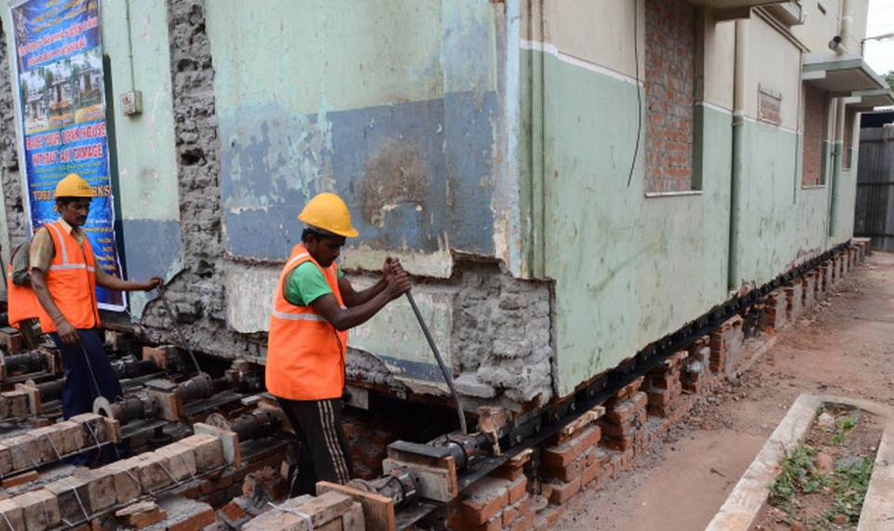

This 2,400 sq. house on Mettupalayam Road has moved 35 feet in the last 19 days. It will move another 10 feet by the end of this month.

The staircase, wooden work in the interiors, tiles, electrical wiring and plumbing lines remain intact as the house shifts 45-feet with the support of 300 rollers and 300 jacks.

When the house owner, Thangavelu, wanted to construct a new building in the front portion of his plot, but without demolishing any part of the existing 50-year-old house, he contacted Haryana-based TDBD Engineering Works. The company is into lifting and shifting of buildings. It responded with a plan to move the existing house backward in order to enable the construction of the new one, so that both could coexist.

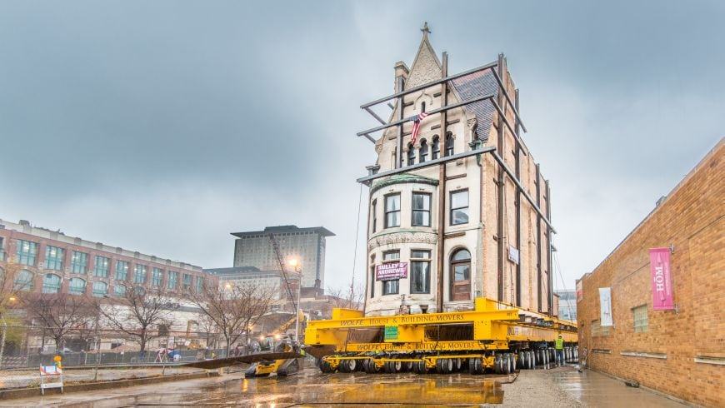**1.9.Gallery**

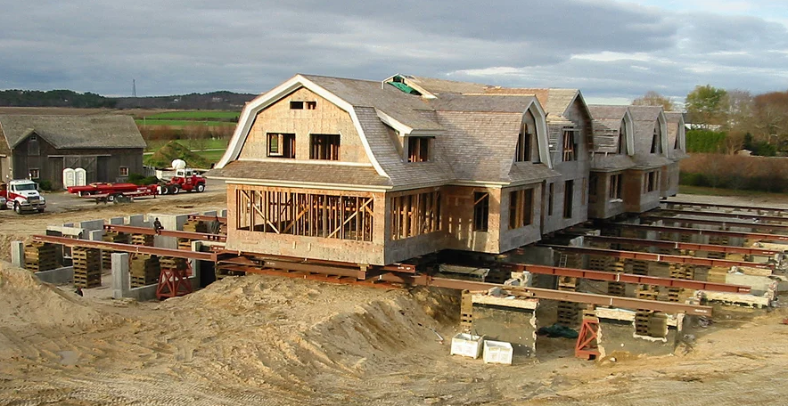

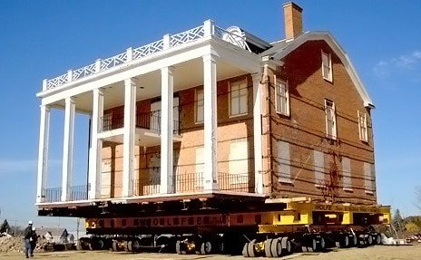

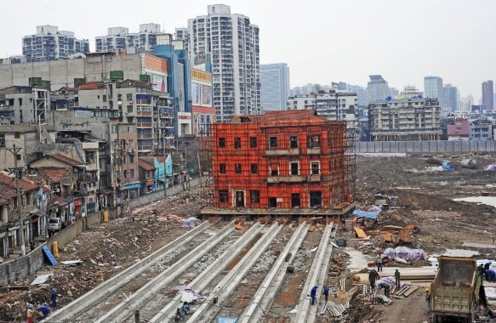

**2.UNDERPINNING**

Underpinning is a method for repair and strengthening of building foundations. Underpinning methods, procedures and their applications in strengthening of different types of foundations is discussed in this article.

There are situations where a failure in foundation or footing happens unexpectedly after the completion of whole structure (both sub and superstructure). Under such an emergency situation, a remedial method has to be suggested to regain the structural stability.

The **method of underpinning** help to strengthen the foundation of an existing building or any other infrastructure. These involve installation of permanent or temporary support to an already held foundation so that additional depth and bearing capacity is achieved.

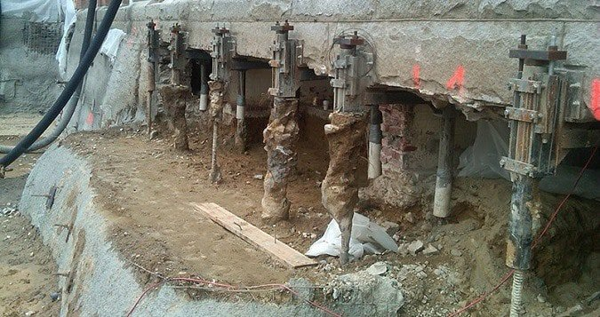

## **2.1Selection of Underpinning Methods**

Underpinning methods are selected based on age of structure and types of works involved.

### Structure categories based on its age:

* Ancient Structures: Age greater than 150 years
* Recent Structures: Age between 50 – 150 years
* Modern Structure: Age less than 50 years

### Types of works for selection of underpinning methods:

#### **Conversion Works**

The structure has to be converted to another function, which requires stronger foundation compared to existing

#### **Protection Works**

The following problems of a building has to undergo protection works:

* The existing foundation is not strong or stable
* Nearby excavation would affect the soil that supports existing footing.
* Stabilization of the foundation soil to resist against natural calamities
* Requirement of basement below an already existing structure

#### Remedial Works

* Mistakes in initial foundation design caused subsidence of the structure
* Work on present structure than building a new one

## Structural Conditions which Requires Underpinning

There are many reasons that make an engineer to suggest underpinning method for stabilization of the substructure such as:

* The degradation of timber piles used as a foundation for normal buildings would cause settlement. This degradation of structures is due to water table fluctuations.
* Rise and lowering of the water table can cause a decrease of bearing capacity of soil making the structure to settle.
* Structures that are built over soil with a bearing capacity not suitable for the structure would cause settlement.

### Need for Underpinning

The decision of underpinning requirement can be made based on observations. When an already existing structures start to show certain change through settlement or any kind of distress, it is necessary to establish vertical level readings as well as at the offset level, on a timely basis. The time period depends upon the how severe is the settlement.

Now, before the excavation for a new project, professionals have to closely examine and determine the soil capability to resist the structure that is coming over it. Based on that report the need for underpinning is decided. Sometimes such test would avoid underpinning to be done after the whole structure is constructed.

## **2.2 Methods of Underpinning**

Following are the different underpinning methods used for foundation strengthening:

* Mass concrete underpinning method (pit method)
* Underpinning by cantilever needle beam method
* Pier and beam underpinning method
* Mini piled underpinning
* Pile method of underpinning

Whatever be the types of underpinning method selected for strengthening the foundation, all of them follow a similar idea of extending the existing foundation either lengthwise or breadthwise and to be laid over a stronger soil stratum. This enables distribution of load over a greater area.

Different underpinning methods are mentioned briefly in the following sections. The choice of method depends on the ground conditions and the required foundation depth.

### 1. Mass Concrete Underpinning Method (Pit Method)

Mass concrete underpinning method is the traditional method of underpinning, as it has been followed by centuries. The method involves extending the old foundation till it reaches a stable stratum.

The soil below the existing foundation is excavated in a controlled manner through stages or pins. When strata suitable is reached, the excavation is filled with concrete and kept for curing, before next excavation starts.

In order to transfer the load from old foundation to new one, a new pin is provided by means of placing dry sand-cement pack. This is a low-cost method suitable for the shallow foundation.

For more complicated problems related to the foundation other superior methods have to chosen.

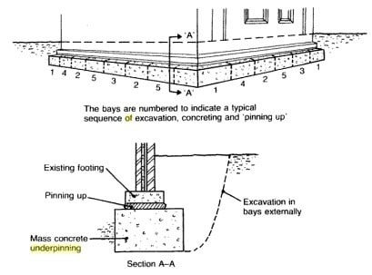

### 2. Underpinning By Cantilever Needle Beam Method

Figure-2 represents the arrangement of cantilever pit method of underpinning, which is an extension of pit method. If the foundation has to be extended only to one side and the plan possess a stronger interior column, this method can be used for underpinning.

**Advantages of Cantilever Needle Beam Method:**

* Faster than traditional method
* One side access only
* High load carrying capability

**Disadvantages:**

* Digging found uneconomical when existing foundation is deep
* Constraint in access restricts the use of needle beams

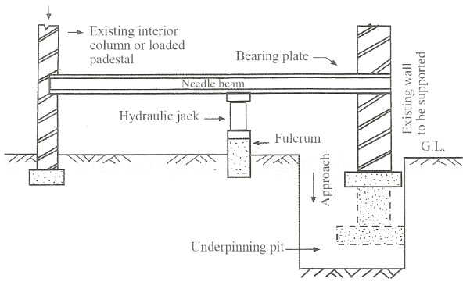

### 3. Pier and Beam Underpinning Method

It is also termed as base and beam method which was implemented after the second world war. This method progressed because the mass concrete method couldn’t work well for a huge depth of foundation.

It is found feasible for most of the ground conditions. Here reinforced concrete beams are placed to transfer the load to mass concrete bases or piers as shown in figure 2.

The size and depth of the beams are based on the ground conditions and applied loads. It is found economical for depth shallower than 6m.

### Pier and Beam Underpinning Method4. Mini Piled Underpinning

This method can be implemented where the loads from the foundation have to transferred to strata located at a distance greater than 5m. This method is adaptable for soil that has variable nature, access is restrictive and causes environmental pollution problems.

Piles of diameter between 150 to 300mm in diameter is driven which may be either augured or driven steel cased ones.

### 5. Pile Method of Underpinning

### Underpinning by Pile Method

In this method, piles are driven on adjacent sides of the wall that supports the weak foundation. A needle or pin penetrates through the wall that is in turn connected to the piles as shown in figure-3.

These needles behave like pile caps. Settlement in soil due to water clogging or clayey nature can be treated by this method

**2.3 Common Problems Encountered in Underpinning**

Though Underpinning is very good for stabilizing an old sinking building of structure, yet all is not well with this technique. There are lot of cases where one will end up with serious problems with Underpinning. Underpinning of an existing foundation is typically required whenever a new excavation compromises the stability of the soils supporting that foundation. underpinning involves extending a building’s foundation downward, usually by adding concrete under the existing foundation wall. It is a specialty operation, which even under the very best conditions, has considerable risk associated with it. There are some conditions that make it even more difficult to perform without causing damage.These are as follows:

(A)**Rubble Foundations**

Older buildings may use foundations composed of large stones, which may or may not be mortared together. These rubble foundations, while perfectly adequate for distributing gravity loads to the soil, are not well suited to bridging over underpinning pits. They lack the continuity that is inherent in reinforced concrete footings, or even unreinforced concrete footings. In some cases, it may not be feasible to underpin these foundations. Instead, it may be necessary to install a retaining wall next to the wall that is designed to withstand the lateral load due to the surcharge.

(B) **High Water Table with Silts and Clays**

In one case that the author investigated, a high-rise building was constructed next to an abutting church. The basements of the highrise building extended several levels below the church, which required underpinning the perimeter foundations of the church. In addition, the presence of a high water table meant the site would need to be dewatered. The underpinning operation for the perimeter footings was mostly successful. However, the church building had interior foundations for walls and columns that were not underpinned. The drawdown of the water table caused consolidation of the silty soils, which in turn caused settlement of these interior elements. The interior walls developed severe cracks and the slab-on-grade experienced extensive settlement. As a result, the building was vacated.

(C)**Sandy Soils**

**Sandy soils pose dual problems**

– They settle when vibrated. Pile driving is one potential source of vibrations. Even if the permanent building does not use piles, the contractor may decide to use piles as part of the temporary soil retention systems. For example, soldier pile walls with wood lagging are commonly used. The settlement caused by vibration of cohesionless soils can affect not only the foundations immediately bordering the excavation, but can also cause settlement of interior foundations and slabs-on-grade.  
– They spill out. Cohesionless soils have no ability to stand vertically. So if sheeting or lagging is not installed as the excavation progresses, sandy soils will spill into the excavation, causing the building to lose foundation support.

**2.4 Benefits of Underpinning System**

The process of underpinning the foundation makes buildings accessible for inspection, correction and improvement. As underpinning is usually undertaken in older homes, older household plumbing, electrical and insulation systems can be replaced with new ones. Also, one will have a new concrete floor. Overall, one will get long term savings in energy, safety and comfort of the entire house.

Foundation underpinning dramatically increases the usability of the below ground space, up to fifty percent of the available room in a house. In doing so basement may simply become an entertainment field, spa, training room, etc.

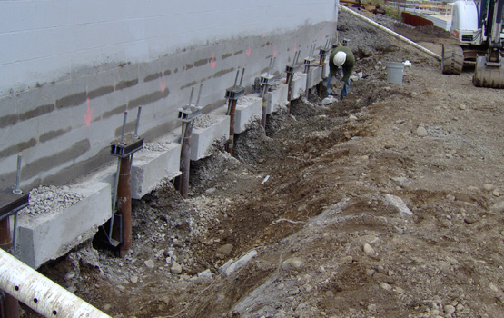**2.5 GALLERY**



**3.Conclusion**

In the construction world, underpinning is a process in which you strengthen and also stabilise a foundation of a building which could be potentially dangerous if no action was taken. A few of the reasons and benefits one should consider are as follow

The existing foundations are not strong / stable enough – underpinning will correct these problems.

The use of the building has changed – Possibly you have changed the purpose of a building, maybe from a house to a shop – underpinning will allow the building to take more pressure.

The soil properties that the building lies upon have changes – there could have been some movement in the ground, perhaps through subsidence – underpinning will help strengthen the building in this case.

New buildings or structures added to the surrounding area. If a new house is build next to an existing property, then underpinning maybe needed to strengthen the first property.

Land cost has increased. If the price of land increases by a great deal, it may be cheaper to use underpinning with a view to improving the existing property (perhaps adding a new floor) rather than purchasing more land.

Hence significant advantages can be gained by early coordination and understanding of the specific requirements that must be met by the underpinning and excavation support systems. Incorporating the design of the underpinning system into the overall project deliverables has the potential of resolving unforeseen problems during construction.

**3.1 Available Resources**

* Flood proofing Info By Southern Tier Central Regional Planning And Development Board.
* FEMA 85. *Manufactured Homes in Flood Hazard Areas: A Multi-Hazard Foundation and Installation Guide*. See Chapter 8, Methods for Mitigating Flood Hazards 8.3 Relocation
* The Constructor Civil Engineering Home